**$400 Hong Kong Dollar Ingredients**

(Including Breakfast, Lunch and Dinner)

* Sau Tao Beijing Noodle 375GM (6 packets) - Enough for 30 meals
  + Brought from ParkNshop supermarket
  + Approximately $5.5 per packet
  + Price: $33

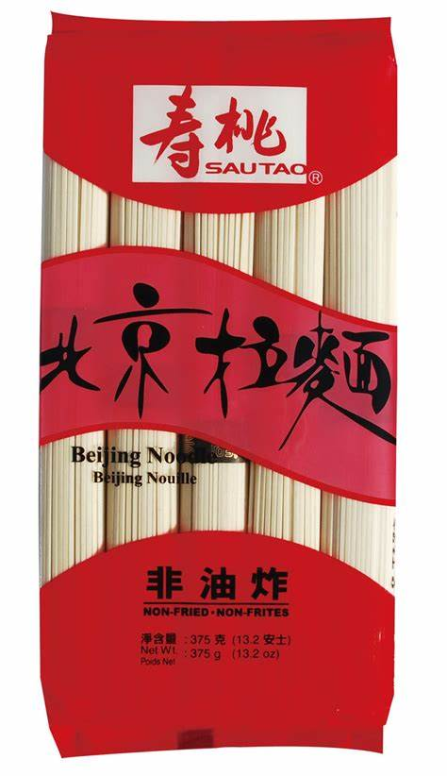

* Instant Noodle 1 box – Enough for 30 meals
  + Brought from U-mart
  + Approximately $99 per box
  + Price: $99

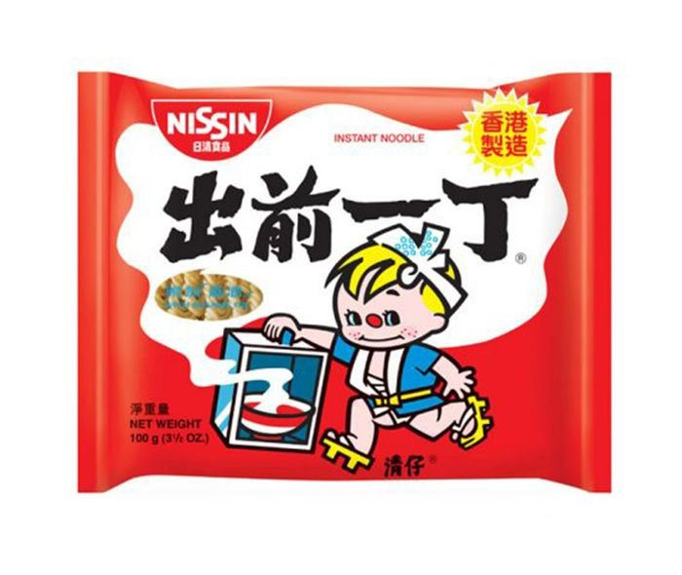

* Red Onion 3 pieces (large)
  + Brought from market
  + Approximately $3.6 for 1
  + Price: $11

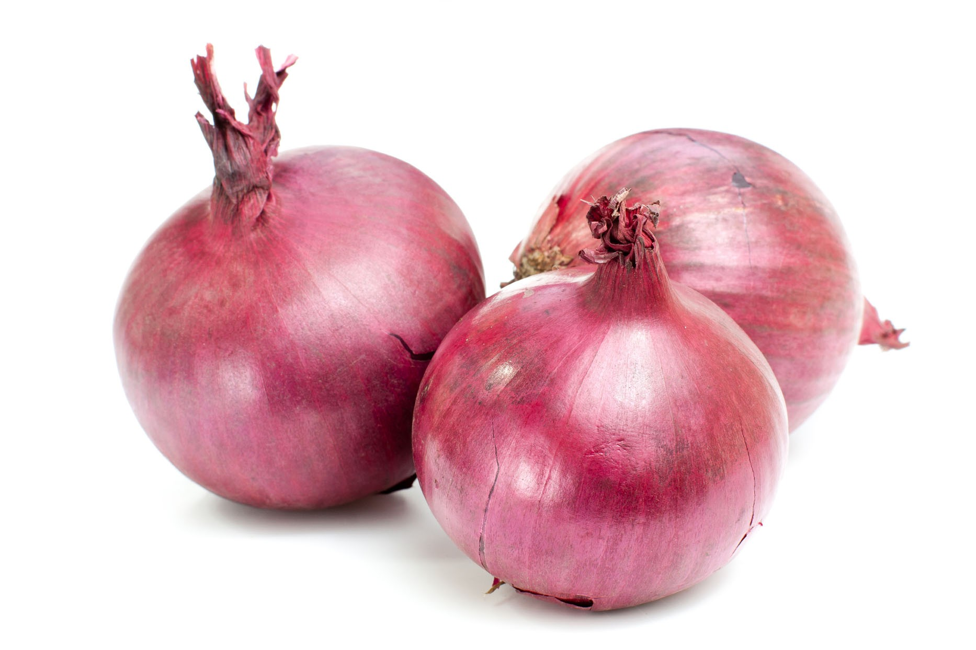

* Potatoes For Curry Chicken 1 packet for 3 potatoes (2 packets ~ 6 potatoes) – Enough for 30 meals
  + Brought from market
  + Approximately $8 for 1 packet
  + Price: $16

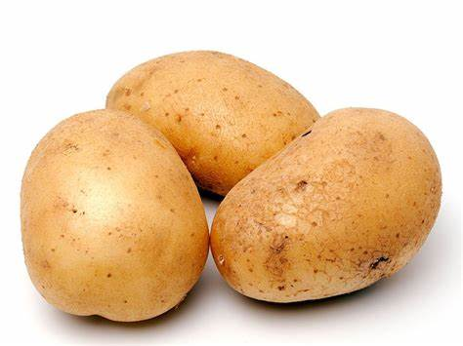

* Best Mart 360 Premium Thai Fragrant Rice 5kg – Enough for 30 meals
  + Brought from Best Mart 360
  + Approximately ~ $49 per packet
  + Price: $49

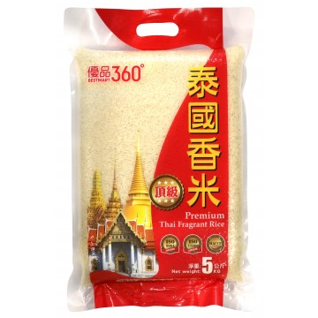

* Chicken Chops for Curry Chicken (Large) 6 Pieces – Enough for 30 meals
  + Brought from market
  + Approximately $9.3 per Piece
  + Price: $55.8

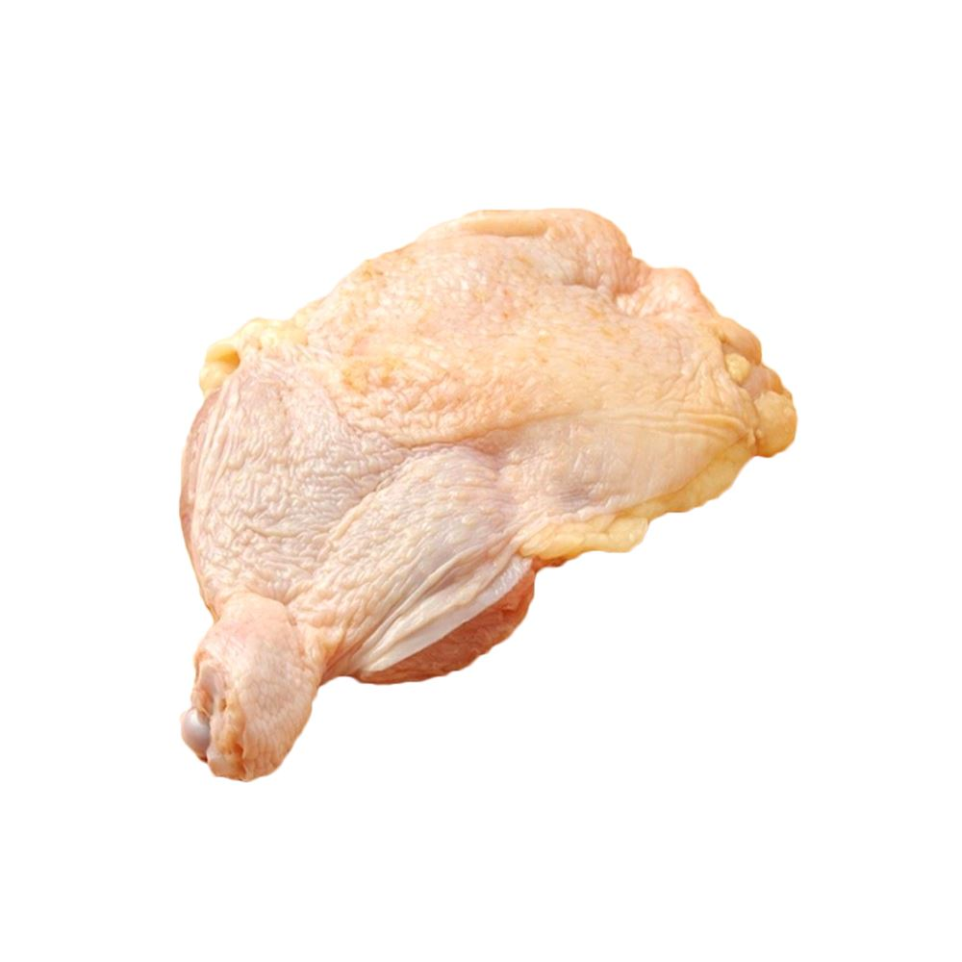

* Curry 3 Bottles – Enough for 30 meals
  + Brought from U-mart
  + Approximately $16.9 per Bottle
  + Price: $50.7

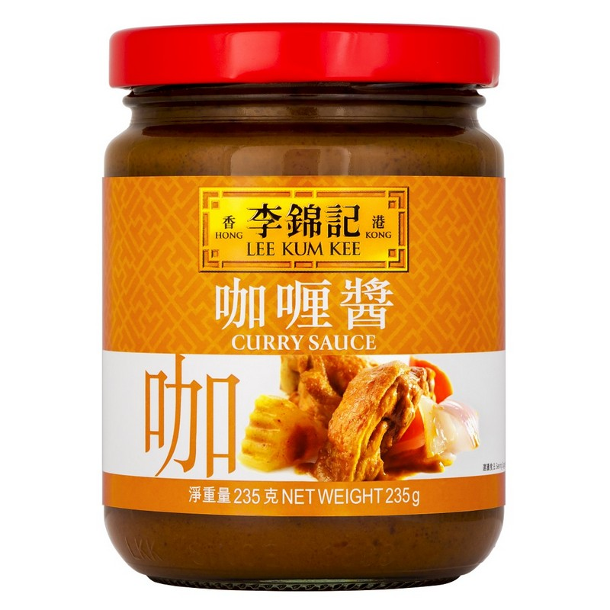

Coconut Milk 396 gram – Enough for 30 meals

* + Brought from Welcome Supermarket
  + Approximately $21.5
  + Price: $21.5

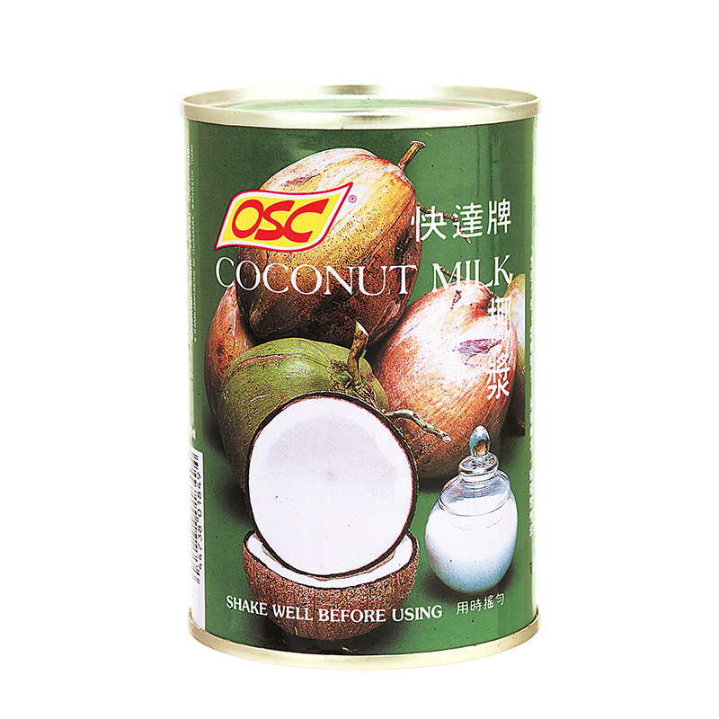

* Chicken Powder – Enough for 30 meals
  + Brought from U-mart
  + Approximately $17 per Can
  + Price: $17

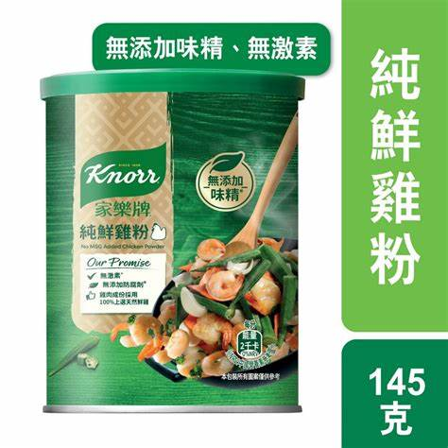

* Vegetable ~ 3kg – Enough for 30 meals
  + Brought from market
  + Approximately $12 For 1kg
  + Price: $36

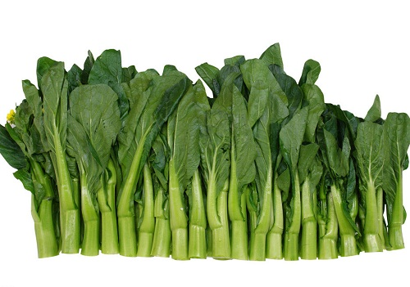

**Total Price: Approximate $389 (All in terms of Hong Kong Dollars)**

*Updated:30th December 2024 price subject to change*

**Meals And Menus (Total 90 Meals)**

3 Meals Per Day (Breakfast, Luch and Dinner) for 90 days

**These ingredients are based on portions. In case you don’t how to accurately divide it into portion. You can use a balance to weight the net weight of the ingredients and then divide it into portions base on the net weight.**

* Beijing Noodle with Vegetable Soup Base *– (30 meals) (Served for Breakfast or Lunch)*

1. Fill the pot with water.
2. Add Chicken Powder.
3. Add one serving size of noodle into the pot.
4. Add a portion of Vegetables into the pot.
5. Served.

* Instant Noodle *– (30 meals) (Served for Breakfast or Lunch)*

1. Fill the pot with water.
2. Add Instant Noodle Flavourings.
3. Add one serving size of instant noodle into the pot.
4. Wait till fully cooked.
5. Served.

* Cury Chicken with Rice *(30 meals) (Served for Dinner)*

1. Unfrozen the chicken.
2. Cut the chicken into small bite sizes.
3. Mixed the chicken with flavour: salt and leave it for half an hour.
4. Keep the chicken inside the fridge.
5. Peel and Cut the Onion into Slices.
6. Peel the potato. Cut into small bite sizes base on your portion.
7. Fill the pot with water (base on your curry portion).
8. When water starts to boil, based on your portion add the Curry inside the pot.
9. Base on your portion, add the potato inside the pot. For fast cooking, you can fry the potato in a pan first.
10. Base on your portion, add Onion and a few bite sizes of chicken into the pot.
11. Base on your portion, add Coconut Milk into the pot.
12. Serve it with **Rice**.

**Recommended Portion for Beijing Noodle with vegetable and chicken Soup base**:

* 1 unit set of noodles (there are total 5 sets per packet).
* Chicken Powder 1 tea Spoon.
* Vegetable ~ add few bunches of vegetables or according to your needs.

**Recommended Portion for Curry Chicken enough for 10 days**:

* 1 bottle of Curry.
* 1 Large Chicken Chop, cut into small dices, around 20 pieces.
* 3 Potatoes.
* 1 Onion.
* 132 ml of Coconut Milk.
* Rice (not cooked) 150 gram.

***Total 90 meals***